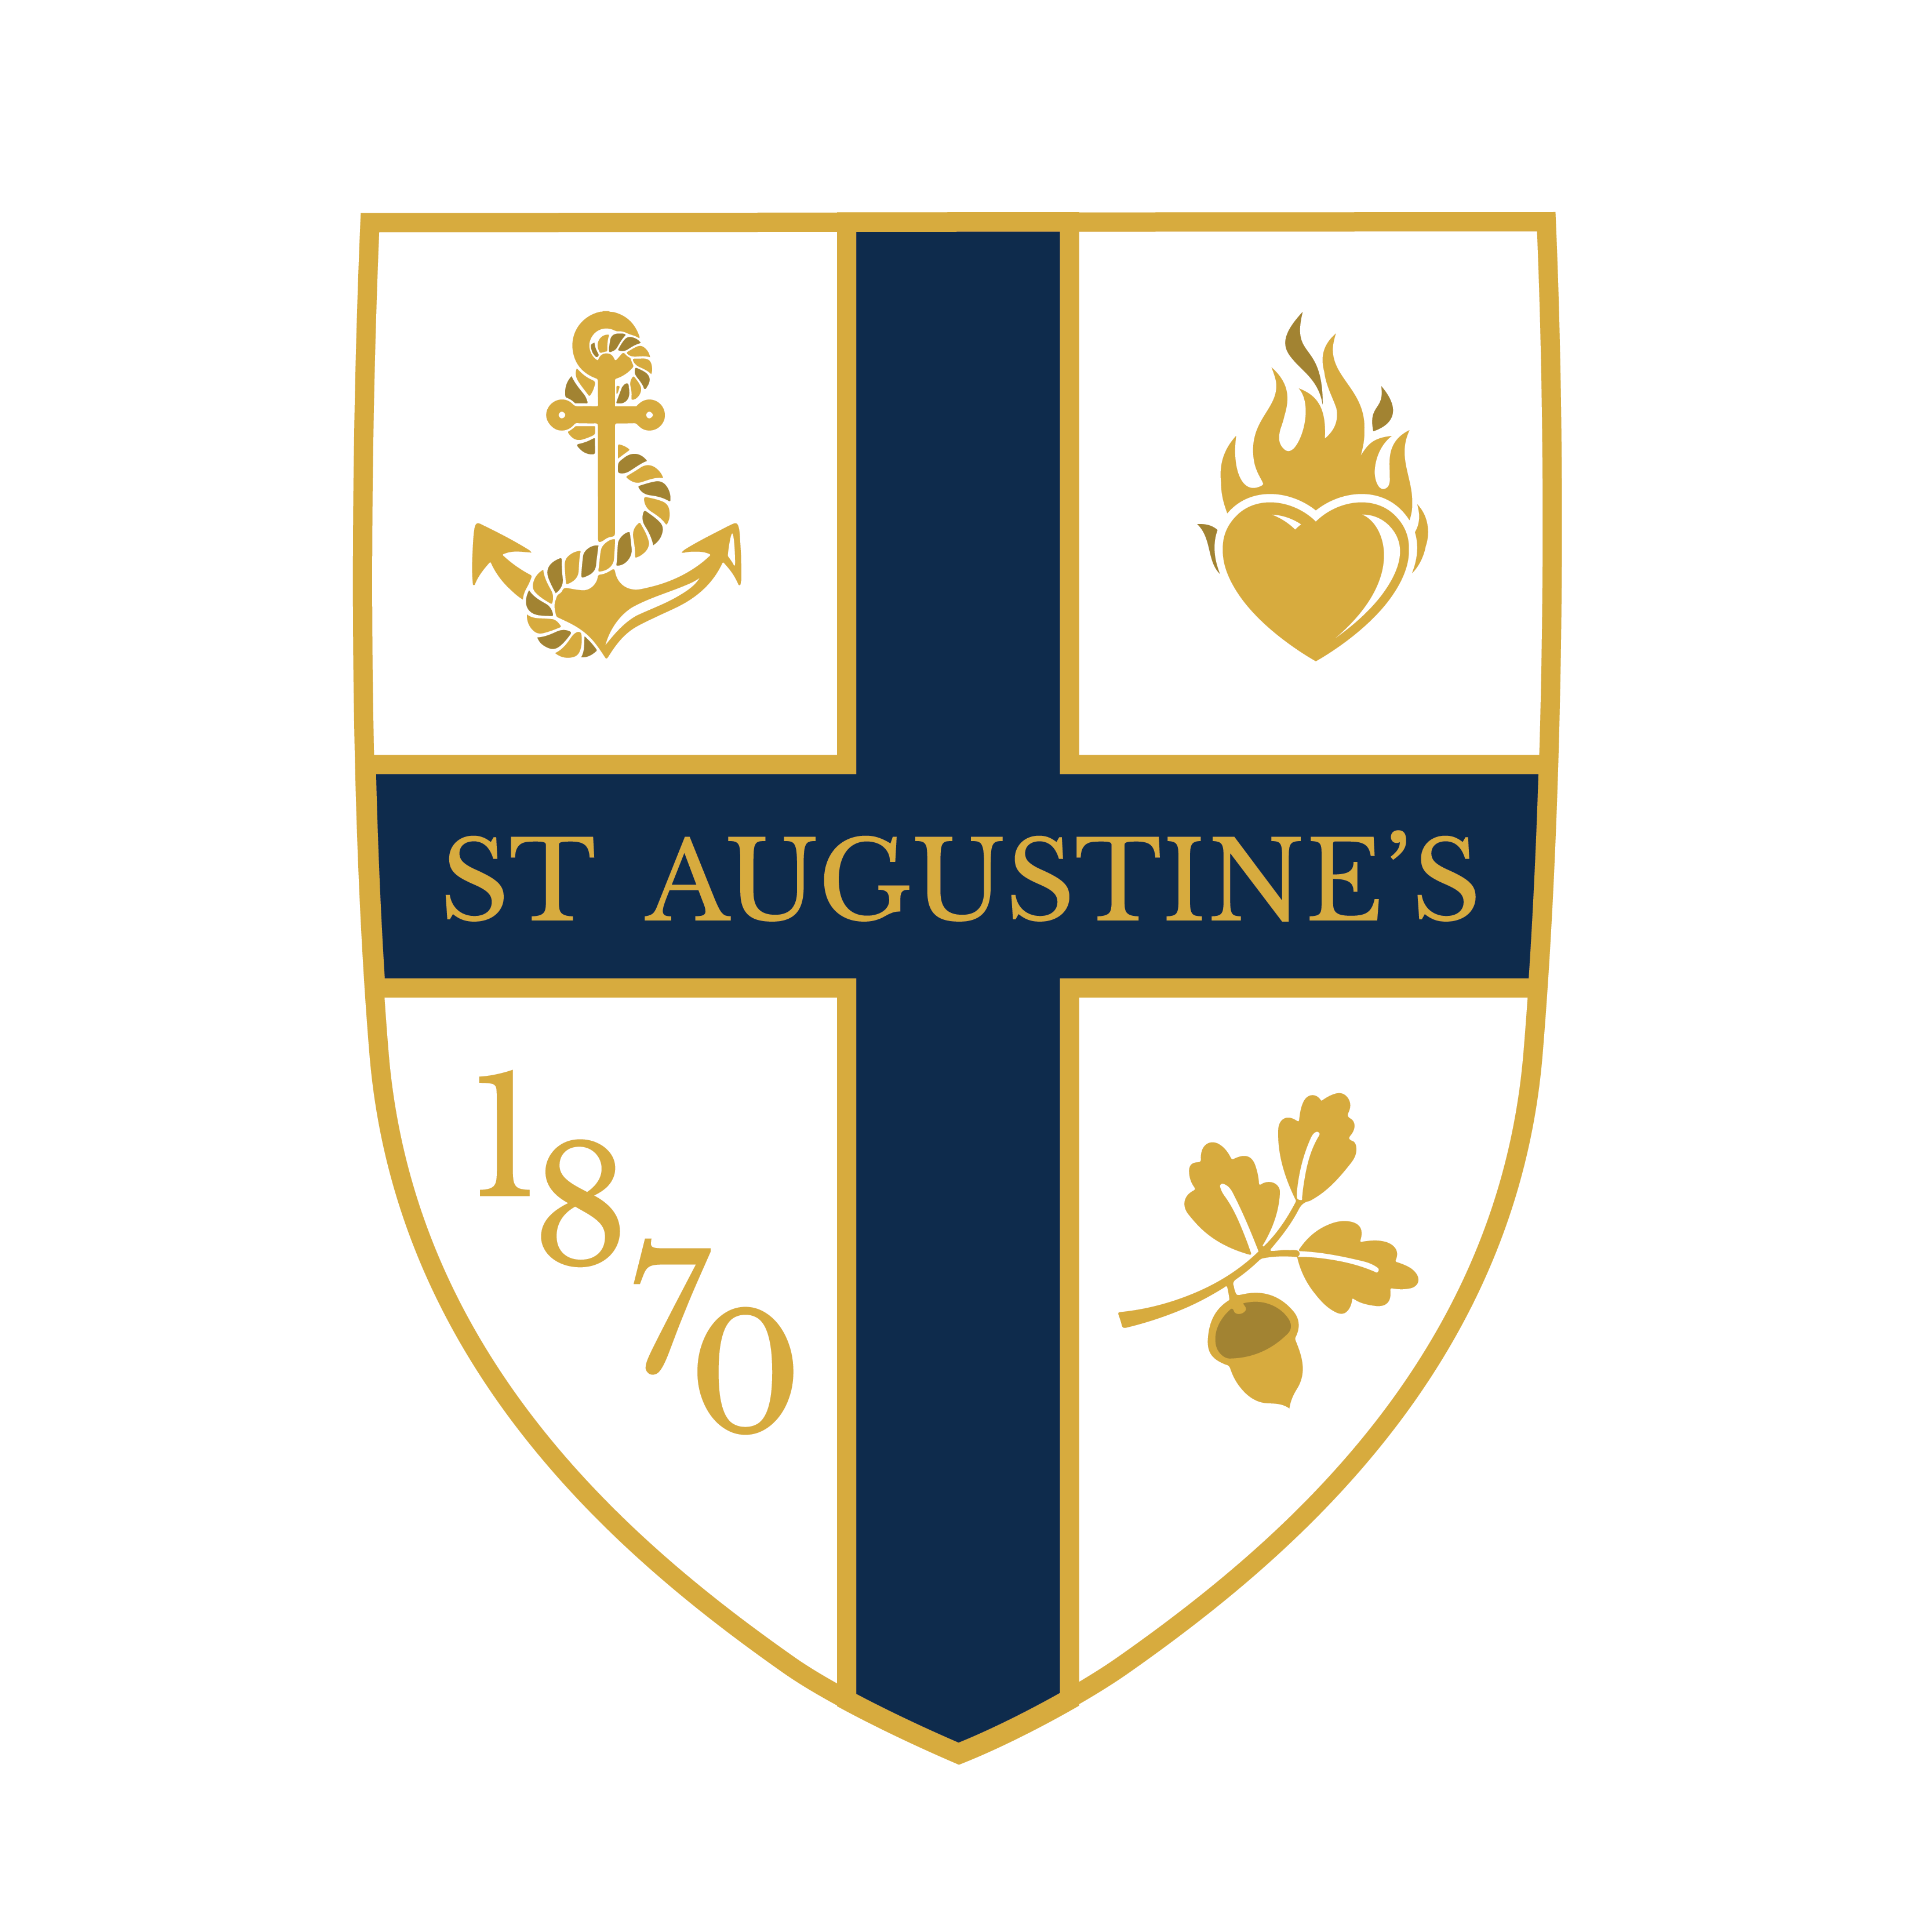

**January 2025**

**Year 3 Newsletter**

**Spring 1**

Welcome back to Spring1 term of Year 3. We hope that you and your child are rested and relaxed and looking forward to another busy and exciting half-term. I am so proud of all the children, especially how they have settled into the class.

**Reminder of routines**

Pupils will continue to go straight to their classrooms from 8.45am and there will no longer be any classes lining up in the playground at the start of the school day. Children in Breakfast Club will go straight to their classes at 8:45am. If your child arrives at school after 9.00am, please ensure that they go to the main school entrance so that they can be recorded in the register. At the end of the school day, children can be collected from the playground, as usual, and teachers will be in the playground after school for informal conversations.

**Topic**

This half term, we will be focusing on Geography. They will be studying ‘Who lives in the Antarctica? Children will describe what lines of latitude and longitude are, giving an example. Understand that the Northern and Southern Hemispheres experience seasons at different times. Define what climate zones are. Understand Antarctica has a polar climate made up of ice sheets, snow and mountains. Describe Antarctica’s location in the far south of the globe. State that tourism and research are the two main reasons people visit Antarctica. Describe equipment researchers might use and clothes they wear. List some of the research carried out in Antarctica. State the outcome of Shackleton’s expedition. Successfully plot four-figure grid references at the point where the vertical and horizontal line meet. Describe a similarity and difference between life in the UK and life in Antarctica. Confidently use the zoom function on a digital map. Begin to recall the eight points of a compass, following at least four of them. Recognise and describe features on their school grounds from an aerial map. Draw a map of the route they take on an expedition. State one thing that went well on the expedition and one aspect that did not go as hoped.

**English: Writing**

In English, this half-term they will begin by focussing on non-fiction narrative writing where they will write a prequel to a film stimulus. Next, the children will focus on non-fiction, where they will be writing formal and informal letters. Finally, the children will write a non-chronological report to the Geographical Society about life in Antarctica

**English: Reading**

The children will continue to read in school on a regular basis, whether independently, in a guided group, or as a whole class, as well as having stories read to them. They will continue to develop their reading fluency but will increasingly focus on understanding more complex texts at a deeper level, developing a range of skills including inference, prediction and summary.

**Maths**

In maths this half term we will be covering a range of areas. This term begins with a focus on calculating with multiplication & division, with pupils developing their understanding of both mental and written multiplication & division. Next, the children will be introduced Time. The children will also learn about how to find fractions of given numbers.

**RE**

The RE, the big question this term will be ‘How does the season of Advent and the feast of the Epiphany point towards the true meaning of Christmas?’ This unit looks at the importance of remembering. To know about the feast days of ‘All Saints Day’ and ‘All Saints Day’ as days the church mark for remembering. They will also understand the importance of peace to believers and how this might be expressed by people of faith. Children will also look at the meaning of the core concept: Incarnation, and to know the meaning of Epiphany and the significance of the wise men to the Christmas story.

|  |
| --- |
|  |

**PE**

PE will be on Tuesday & Thursday. The children can wear their PE kits into school on these days and will wear them home. For the PE kit, they will need a white polo shirt, navy shorts or jogging bottoms and all black trainers without a coloured trim.

**Homework**

An English homework, usually based around a spelling challenge, and maths homework will be sent home every Friday. Please support your child with the learning of their times tables. The homework then needs to be handed in by the following Wednesday. Please support your child with the work, but do encourage as much independence as possible. Let us know if you have any questions about the homework.

**Home-school Reading**

Each week, children will take home a book appropriate for their current reading level. Please read with them, and talk about what they have read, for at least 20 minutes every day. Your child will be bringing home a new reading record; please use this to make a note of what they have read, as well as to add a comment at least once a week. The reading record should be returned to school on Wednesday, with the homework, so which we can add our own comments.

**Key Dates**

|  |  |
| --- | --- |
| **Date** | **Event** |
| Friday 14th February 2025 | Last day of term |
| Monday 24th February 2025 | First day of new term |

It is a pleasure to have you all back in school together. If you would like to discuss any concerns with us, please make an appointment with the school office.

Best wishes,

The Year 3 Team